**ShopNest Power BI Capstone Project**

**1.**  **Identify the rating distribution in the Shop Nest dataset, showcasing ratings categorized as Excellent, Very Good, Good, Bad, and Very Bad, along with corresponding orders.**

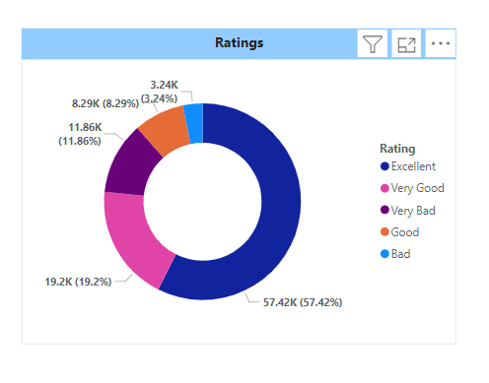

* The chart shows that most ratings for the Nest Store are "Excellent" (57.42%), followed by "Very Good" (19.2%), with fewer ratings for "Very Bad" (11.86%), "Good" (8.29%), and "Bad" (3.24%).

**2. What are the top 10 and bottom 18 most popular product categories in the ShopNest dataset? Please list them based on the number of orders.**

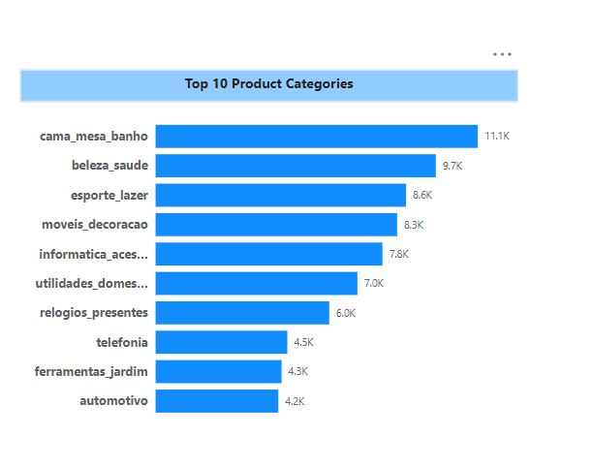

* The chart displays the top 10 product categories based on popularity or sales. The leading category is "cama_mesa_banho" with 11.1K, followed by "beleza_saude" with 9.7K, and "esporte_lazer" with 8.6K. The categories with the lowest values in this list are "telefonia" (4.5K), "ferramentas_jardim" (4.3K), and "automotivo" (4.2K). It highlights the relative popularity or sales volume across different product categories.

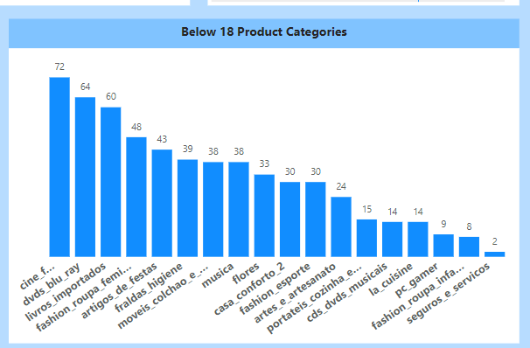

* The chart shows the count of orders for various product categories that are classified as "Below 18." The categories are ranked based on the number of orders, with "cine_f..." (likely referring to cinema-related products) leading with 72 orders, followed by "dvds_blu_ray" (64 orders) and "livros_importados" (60 orders). Other categories like "fraldas_higiene" have 39 orders, and the least ordered categories include "fashion_infanto_juvenil" (8 orders) and "seguros_e_servicos" (2 orders). This chart highlights the distribution of orders across different categories in this segment.

**3. List the total number of active sellers by yearly and monthly.**

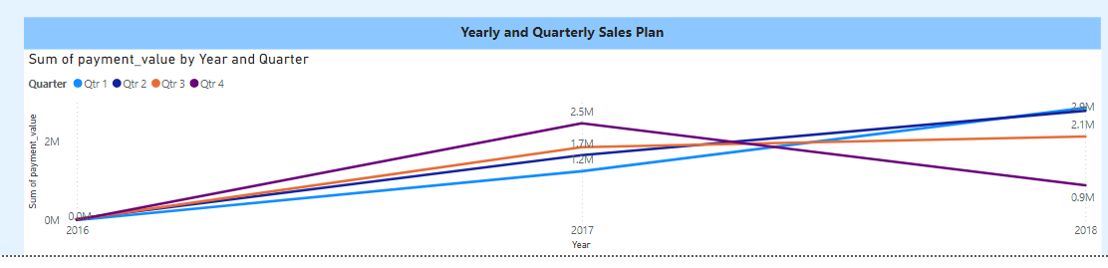

* In 2016, all quarters start at roughly the same point with low values.

By 2017, the sum of payment values increases significantly, peaking in some quarters.

* **Quarter 1** (blue line) shows the most growth by 2018, reaching over 2.9M.
* **Quarter 4** (purple line) peaks at around 2.5M in 2017, but then declines sharply in 2018.
* **Quarter 2** (orange) and **Quarter 3** (red) show more stable and modest growth.
* This chart tracks the payment values for each quarter from 2016 to 2018, showing fluctuations, especially in 2017 and 2018, with Quarter 1 experiencing the most substantial growth by 2018.

**4. Which payment methods are most commonly used by ShopNest customers.**

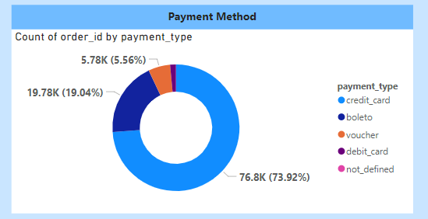

This chart shows the distribution of payment methods for orders.

* **Credit card** is the most used method, accounting for **73.92%** of orders.
* **Boleto** makes up **19.04%**.
* **Voucher** accounts for **5.56%**.
* **Debit card** and **not defined** are very small portions.

So, the most commonly used payment method is Credit Card.

**5. Identify the product category, wise profit margin using the formula.**

**Hint: (Payment value-price + Freight_value)/payment_value*100 (Rounded to two decimal points).**

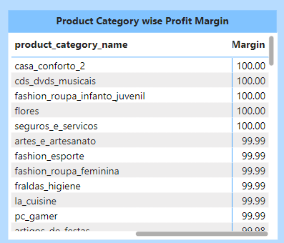

In this Table Chart, we can see that the “casa_conforto_2 has highest profit margin of “100” followed by “cds_dvds_musicians “ with “ 100” followed by “fashion_roupa_infanto_juvenil” with “100”.

**6. Determine the monthly payments made by customers using credit cards**.

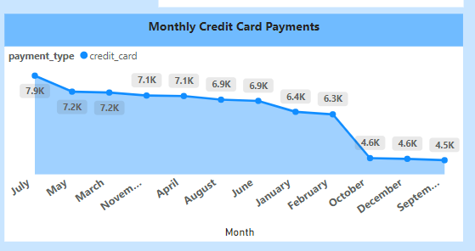

This chart shows the **monthly credit card payments** over a period of time.

* The number of payments starts at **7.9K** in **July** and gradually declines.
* Payments remain steady around **7.1K** to **7.2K** between **November** and **April**.
* A noticeable drop occurs after **June**, reaching **4.6K** by **October** and **December**, and further decreasing to **4.5K** in **September**.

In summary, credit card payments show a downward trend over the months, with a significant drop starting around mid-year.

**7. Identify sellers categorized by city, excluding cities starting with the letters S and B.**

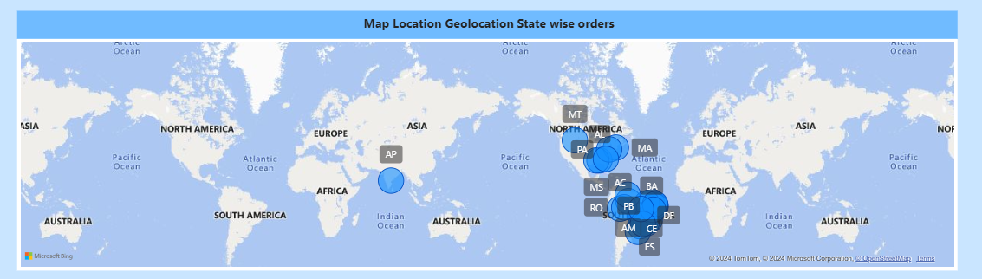

This map chart shows the sellers categorized by city, excluding cities starting with the letters S and B.

**8. Create a dynamic visual that compares the number of delayed orders to the number of orders received earlier for each month. Utilize the drill through the cross-report feature to provide a detailed analysis of late and on-time deliveries.**

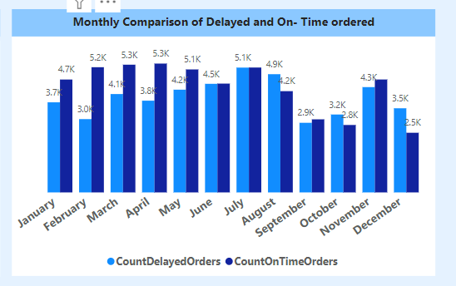

The chart compares the number of delayed (light blue) and on-time (dark blue) orders for each month.

* May and August have the most delayed orders.
* July and May show high on-time orders.
* October and February have the fewest delayed orders.

It shows the fluctuations in order performance throughout the year.

**Product Level Analysis Dashboard**

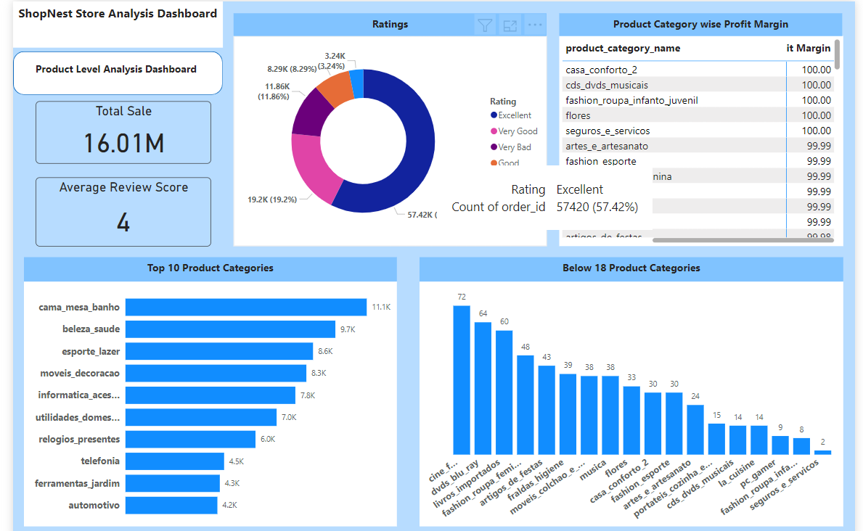

**Order Level analysis Dashboard**

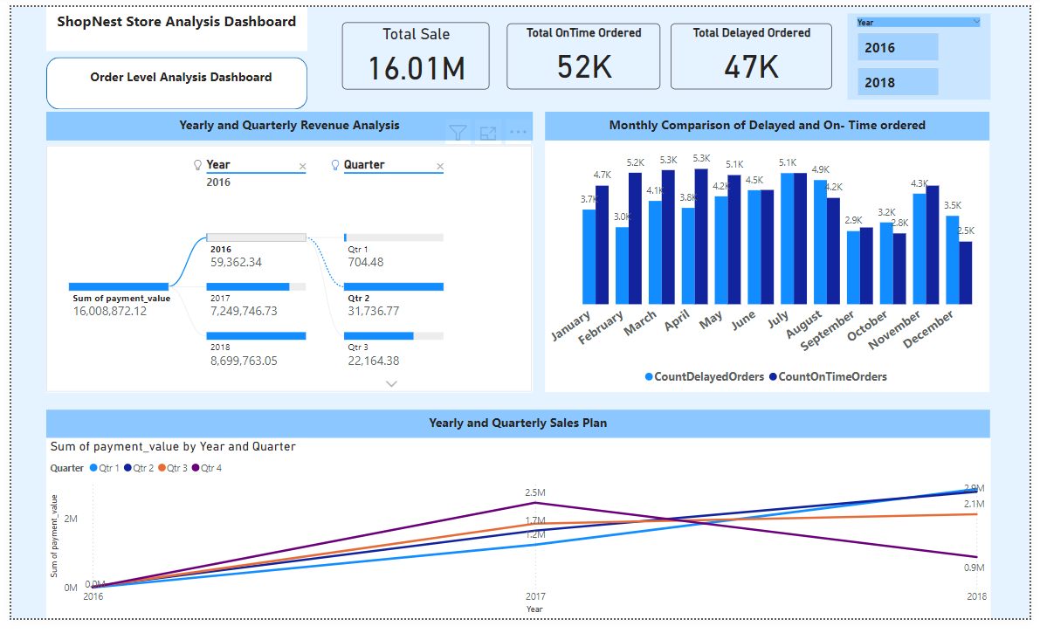

**Customer Level Analysis Dashboard**

